**Conservation of Linear Momentum**

Dessa Shapiro Period 3

**Introduction/Background:** What happens to momentum during a collision?

**Why are we doing this?/Activity Goals:** To understand how to land a spacecraft on a planet, we need to understand momentum and the consequences of momentum transfer between objects.

**Phenomena/Observations to be Explained:** Newton’s Cradle and other collisions

**Essential Questions/Focus Questions:** What rules govern collisions between objects?

**Part A: Elastic Collisions with Equal Masses**

Materials - Each small group will need:

A flat lab benchtop surface

Steel Ball Bearing Track

Masking tape

Up to ten ¾” steel ball bearings, all the same size, or glass marbles.

Other assorted smooth marbles or steel balls, of varying sizes up to 1” in diameter.

A dish or tray to contain the marbles and balls.

Set up a track: Work to make sure your track is “level” on the table which you are working. It may take some maneuvering to find the right angle.

Place one ball in the middle of the track. From one end of the track, use your hand to start a second ball rolling towards the first one, fast. Observe what happens to each ball after they collide. Most (but not all) of the momentum gets transferred to the ball that got hit. Do both move “fast” afterwards, or just one? (Rolling “fast” means moving about as fast as the moving ball before the collision.) **From your observations, draw both balls placements before the collision and after the collision.**

| Before the collision | After the collision |
| --- | --- |

Try the same thing with two balls in the middle, touching each other, hit by a third. First, predict what you think will happen. Draw what you observe below.

**Prediction:** I predict that when the ball hits the 2 the ball the one end will move the fastest in the opposite direction, absorbing the most force( movement) and the other two will move very slowly or not at all in the same direction.

| Before the collision | After the collision |
| --- | --- |

Try it with two balls hitting two balls, one ball hitting three, two balls hitting four, etc, etc. Each time make a prediction *verbally* with your group first. Fill out this table (share balls with other groups if there aren’t enough):

| **Part A Data Table** | Number of balls rolling fast *before* the collision: | | | | |
| --- | --- | --- | --- | --- | --- |
| Number of stationary balls in the middle of the track that get hit:  (they should touch each other) |  | 1 | 2 | 3 | 4 |
| 1 | 1 | 2 | 3 | 4 |
| 2 | 1 | 2 | 3 | 4 |
| 3 | 1 | 2 | 3 | 4 |
| 4 | 1 | 2 | 3 | 4 |

(Record the total number of balls moving ***fast*** after the collision

= they separate themselves from the group at a similar speed)

Make a general statement that relates the number of balls traveling fast before to the number of balls traveling fast afterwards.

**My statement:** the amount of balls going “fast” at the beginning with alway be the same as the amount of balls going “fast” at the end( correlate)

**Part B: Elastic Collisions with Different Masses**

Take two kinds of balls/marbles of unequal masses; preferably where one is about double the mass of the other. We will call these the “heavy” and “light” balls. Try the following collisions; circling the result on the table below.   
A score of “3” means moving after the collision at about the same speed as the moving ball before the collision.  
Before each trial, make a prediction first. (Highlight and **bold** the answers you come up with)

| **Part B: Elastic Collisions with Different Masses  DATA TABLE** | “Light” balls: | | “Heavy” balls: | |
| --- | --- | --- | --- | --- |
| Speed | Direction | Speed | Direction |
| Heavy ball collides with stationary light ball | 1 2 3 4 **5** | **F** R | 1 2 **3** 4 5 | **F** R |
| Light ball collides with stationary heavy ball | 1 **2** 3 4 5 | F **R** | 1 2 **3** 4 5 | **F** R |
| Two heavy balls collide head-on, each going at the same speed | (N/A) | (N/A) | 1 2 **3** 4 5 | F **R** |
| Invent your own: two lights hitting stationary heavy ball | **1** 2 3 4 5  1 2 **3** 4 5 | **F** R  F **R** | 1 **2** 3 4 5 | **F** R |
| Invent your own: one light and one heavy ball collide head-on, each going at the same speed | 1 2 3 **4** 5 | F **R** | 1 2 **3** 4 5 | **F** R |
| Circle the Results of the collision:  1 = stop 2 = moves slow 3 = moves original speed 4 = moves fast 5 = moves very fast  F = continues forward R = reverses direction | | | | |

**Analysis/Conclusions**

**Momentum** = defined as mass x velocity.   
**Velocity** is not quite the same thing as speed; it also has a direction.   
On your track there are only two directions, (+) and (-) (Forward and Reverse)   
**Conservation of Momentum** refers to the idea that the total momentum in a system after a collision is the same as before the collision.

1. Do your results from Part A support the idea of conservation of momentum? Explain why or why not, using numbers. Yes it does support the idea of conservation of momentum because all the numbers were congruent with the number of balls originally moving and this shows that the momentum ended up being the same and the amount of energy/ momentum never changed it just transferred.
2. When two marbles of the same mass but opposite velocities collided head-on in part B, they moved away in opposite directions with the same speed as before. Explain why, in terms of conservation of momentum.

They reacted like this because the momentum of each transferred to the other upon collision making them move in the opposite direction at the same speed. SO all the momentum was there and if they had stopped the momentum would not have been conserved.

1. Suppose you throw a heavy rock (but not as heavy as you! maybe 20 pounds.) away from you while standing on a skateboard on a level surface. Describe your momentum before, and after. Describe the momentum of the rock before, and after. How about your velocity before and after? (Fast, slow, zero? What direction? The rock’s velocity before and after? (Fast, slow, zero? What direction?) What will happen if you go through the motions of throwing the rock but decide not to let go at the last moment?

Before you would be stationary and after you would move and gain velocity in a reverse direction that you threw the rock. The rock would increase its momentum as it is thrown as before it was stationary with no to little momentum. The rock would go fast if you threw it with enough force and you will go slow in the opposite direction. If you go through the motions of throwing the ball you would most likely fall forward or move forward because of the directed force, thus momentum would be sent in the direction you are throwing the rock.

1. A 20-gram marble moving at 1 meter/second hits a 20-gram marble that is stationary. After the collision the first marble is stationary. Make a sketch of the event. How fast is the second marble moving afterwards?

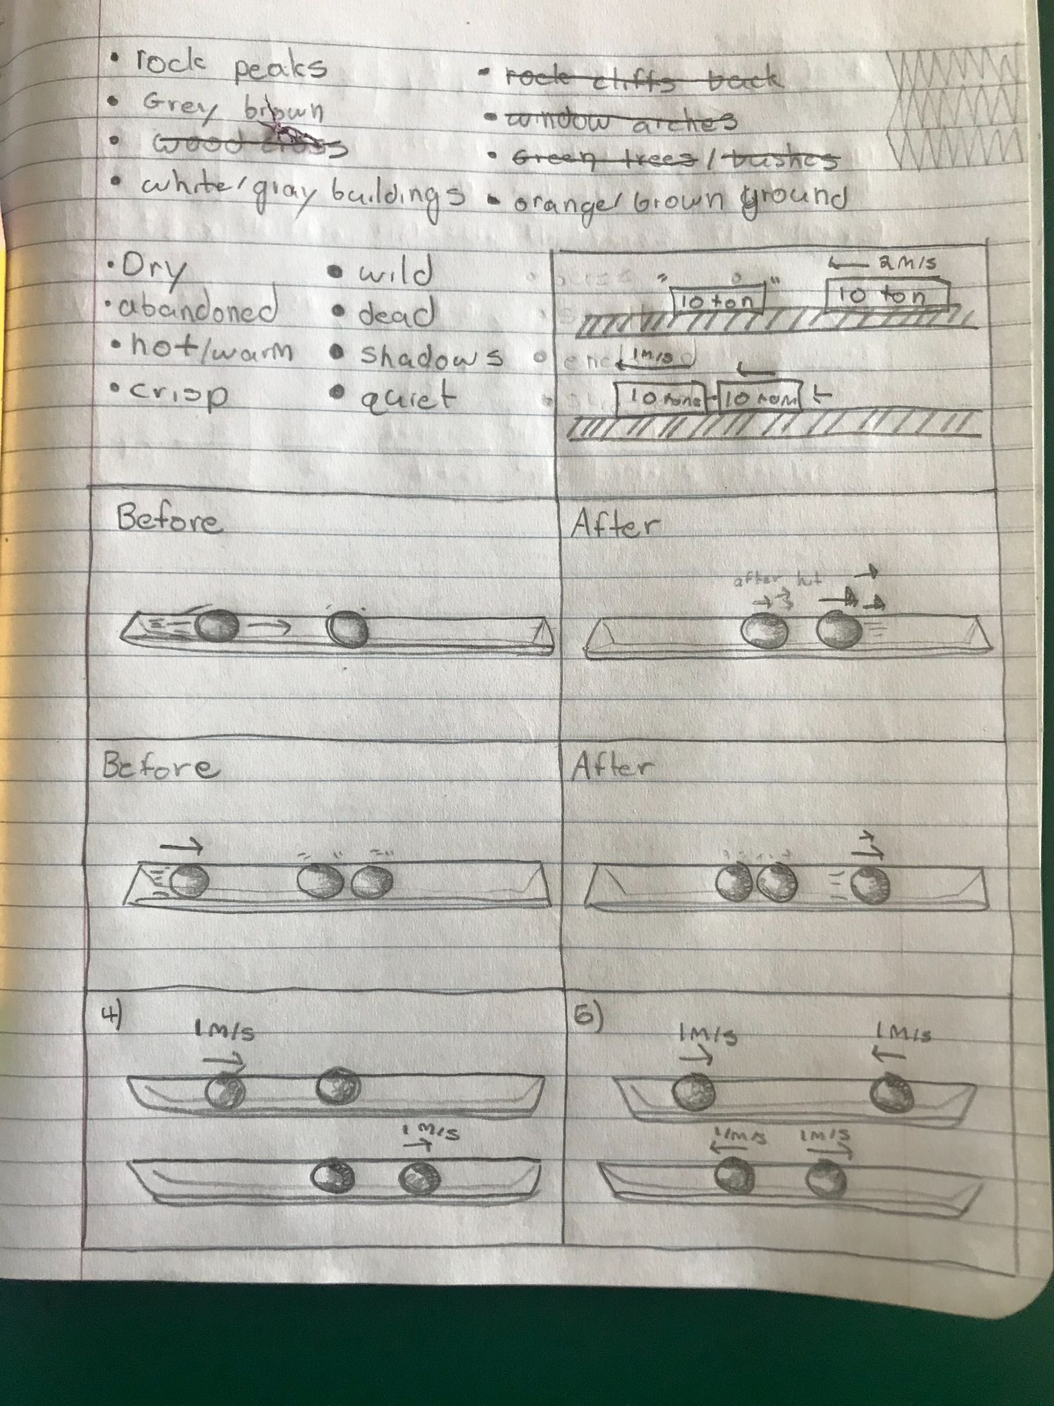

The second marble is moving 1 meter/second afterwards because the momentum is fully transferred and the original ball is stationary at 0 so that must mean it was all given to the other ball.

1. A 20-gram marble moving at 1 meter/second hits another 20-gram marble coming towards it at 1 meter/second . Make a sketch of the event. How fast is each marble moving afterwards?



Each marble would go 1 meter/second still because much like the last answer there momentum of each ball is transferred to the other, it could possibly be a little less because of energy lost in the air / surrounding materials of the collision but f will be very close to 1.

1. A ten-ton railroad car moving at 2 meters/second slams into another ten-ton railroad car that is sitting stationary on the track. During the collision they couple, so afterwards the two move down the track joined together, at the same speed. Make a sketch of the event. How fast are the two railroad cars moving afterwards?



They would be moving at around 1 meter/second because the mass of the two trains is 20 tons which is twice the amount as the train going 2 m/s and because the mass is larger the speed will be smaller to balance the scales.